|  |  |
| --- | --- |
|  |  |
| Plate Buckling Analysis | |
| User Manual | |
| April 25, 2018 | |



|  |  |  |  |  |  |
| --- | --- | --- | --- | --- | --- |
| Rev | Description | Date | Prep | Chk'd | Apprv'd |
| 01 | New Document | 25-April-2018 | VA |  |  |
|  |  |  |  |  |  |
|  |  |  |  |  |  |

Revision History

|  |  |  |  |
| --- | --- | --- | --- |
| Rev | Description | Section | Pages |
| 01 | New document | - | - |
|  |  |  |  |
|  |  |  |  |

CONTENTS

1 INTRODUCTION 3

2 Plate BUCKLING. 3

2.1 Inputs. 3

2.2 Calculation. 5

3 THEORY 11

3.1 Introduction 11

3.2 Input and Output Data Specification 12

3.2.1 Overview 12

3.2.2 Data Flow. 14

3.2.3 Data Cleansing. 14

3.3 Downhole card. 14

3.3.1 Fourier Series. 15

3.3.2 Finite Difference. 15

3.3.3 Damping coefficient. 15

3.4 Downhole card Analysis. 16

3.4.1 Fluid Load. 16

4 GUIDANCE NOTES 17

4.1 Business Use 17

4.2 Service Delivery 17

4.2.1 Error Log 18

4.3 Programming 18

4.3.1 Code Layout 18

4.3.2 File Description. 19

5 FUTURE IMPROVEMENTS 21

5.1 Technical 21

5.2 Computational Performance 21

5.3 Project Management 21

6 References. 21

# INTRODUCTION

Dynacard data program evaluates the analytics application performs the following:

* The guidance for service delivery in section XX
* The user manual for developer in section XX

The document contains the following:

* Guidance notes for business users in Sub-section 2.1
* Guidance notes for service delivery in Sub-section 2.2
* Guidance notes for developer in Sub-section 2.3

# Plate BUCKLING.

## Inputs.

The following shows how to determine the inputs for a plate buckling calculations and these inputs have been read through munch module.

* import munch
* plateGData1 = {'PlateLength': 2.69, 'PlateLength_unit' : 'm',
  + 'PlateBreadth' : 0.70, 'PlateBreadth_unit' : 'm',
  + 'PlateThickness' : 0.014, 'PlateThickness_unit' : 'm',
  + 'AverageWaterDepth' : 40, 'AverageWaterDepth_unit' : 'm',
  + 'YieldStrength' : 34 , 'YieldStrength_unit' : 'ksi',
  + 'PoissionsRatio' : 0.30,
  + 'YoungsModulus' : 30450, 'YoungsModulus_unit' : 'ksi'}
* plateGDataFT1 = {'PlateLength': 8.82, 'PlateLength_unit' : 'ft',
  + 'PlateBreadth' : 2.30, 'PlateBreadth_unit' : 'ft',
  + 'PlateThickness' : 0.046, 'PlateThickness_unit' : 'ft',
  + 'AverageWaterDepth' : 131.23, 'AverageWaterDepth_unit' : 'ft',
  + 'YieldStrength' : 34 , 'YieldStrength_unit' : 'ksi',
  + 'PoissionsRatio' : 0.30,
  + 'YoungsModulus' : 30450, 'YoungsModulus_unit' : 'ksi'}
* plateGLoading1 = {'LongtudinalStress' : 0.5, 'LongtudinalStress_unit' : 'ksi',
  + 'TransverseStress' : 0.5, 'TransverseStress_unit' : 'ksi',
  + 'ShearStress' : 0.7, 'ShearStress_unit' : 'ksi'}

# How to access objects from above dictionaries (also same for JSON format files)

* constantGvalue1 = {'BucklingFactor' : 0.26,

'BCedges_simplysupported_long': 4,

'BC_sideclamped_long' : 7.00,

'Resulting material factor': 1.15,

'H4' : 101325,

'H5' : 1025 ,

'H6' : 9.81,

'H7' : 0.000145038,

'H8' : 0.001,

'BR_transversedirection' : 1,

'Integralfactor' : 0,

'BA_sheardirection' : 1}

The script below shows how to read above inputs through munch module.

* constantGvalue = munch.munchify(constantGvalue1)
* plateGData = munch.munchify(plateGData1)
* plateGDataFT = munch.munchify(plateGDataFT1)
* plateGLoading = munch.munchify(plateGLoading1)
* l_G = plateGDataFT["PlateLength"]
* s_G = plateGDataFT["PlateBreadth"]
* t_G = plateGDataFT["PlateThickness"]
* d_G = plateGDataFT["AverageWaterDepth"]
* f_G = plateGDataFT["YieldStrength"]
* p_G = plateGDataFT["PoissionsRatio"]
* E_G = plateGDataFT["YoungsModulus"]
* L_G = plateGData["PlateLength"]
* S_G = plateGData["PlateBreadth"]
* T_G = plateGData["PlateThickness"]
* D_G = plateGData["AverageWaterDepth"]
* σG_xx = plateGLoading["LongtudinalStress"]
* σG_yy = plateGLoading["TransverseStress"]
* τ_G = plateGLoading["ShearStress"]
* k4_G = constantGvalue["BucklingFactor"]
* c_xx = constantGvalue["BCedges_simplysupported_long"]
* cxx = constantGvalue["BC_sideclamped_long"]
* ϒ_M = constantGvalue["Resulting material factor"]
* x7 = constantGvalue["H4"]
* x8 = constantGvalue["H5"]
* x9 = constantGvalue["H6"]
* x10 = constantGvalue["H7"]
* x11 = constantGvalue["H8"]
* C_τ = constantGvalue["BR_transversedirection"]
* ci_1 = constantGvalue["Integralfactor"]
* C_τe2 = constantGvalue["BA_sheardirection"]

# THEORY

Please add theory

# GUIDANCE NOTES

Guidance notes is provided for the following users:

* Business use
* Service Delivery
* Programming Development

The level of details included in each of the following subsections varies and is dependent on the audience.

## Business Use

TBA

For further details on the theory, see Section 0.

## Service Delivery

* The high level program flowchart is shown in Figure 2.1.
* To deploy the application in production:
  + Utilize the script commands to run the program.
  + An example bat file is also included.
* The log file help troubleshoot service delivery problems.
* The log file contains the following information:
  + Fourier series or finite difference methodology utilized for the calculation
  + Run time for each program call
* To troubleshoot in more detail, refer details in section 2.3.

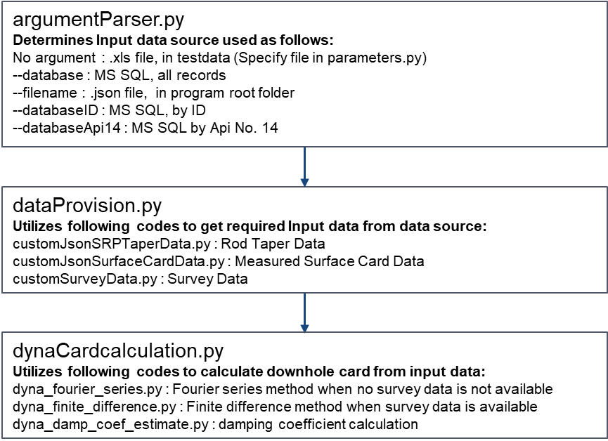

Figure 3‑1.DynaCard FlowChart

### Error Log

* Taper Data
* When the rod data has sections less than the length/Number of finite difference divisions then the program may not run
* When modulus of elasticity is zero for a any rod section, the program will not run.

## Programming

### Code Layout

* The standard folder structure described in Appendix B is utilized for the program.
* The high level program flowchart and the service delivery instructions are given in Section 2.2.
* The main program file contents are highlighted in Figure 2.1.

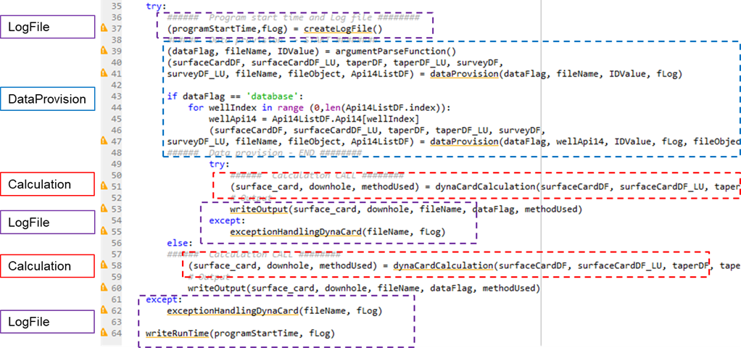

Figure 3‑2.Main Program File Contents

### File Description.

|  |  |
| --- | --- |
| **Folder/File** | **Description** |
| **Folder: DynaCard** |  |
| dynaCard.py | Main program |
| 3Run_Env.bat | Code is used for batch run in scheduler |
| **Folder: DynaCard\lib\Calculations** | |
| dynaCardCalculation.py | Calculation file to choose between Fourier series or finite difference |
| dyna_fourier_series.py | Fourier series calculation method |
| dyno_finite_difference.py | Finite difference calculation method |
| dyno_damp_coef_estimate.py | Damping coefficient estimation code |
| **Folder: DynaCard\lib\dataProvision** | |
| dataProvision.py | The main code to provision required data in a customized manner to the program. This function calls customized data query |
| parameters.py | Parameters or variables with configuration data, SQL que |
| argumentParseFunction.py | To parse the input arguments. |
| customJsonSRPTapperData.py | To get the sucker rod pump taper rod data from data source |
| customJsonSurfaceCardData.py | To get the surface card data for a given well using API No. 14 from data source |
| customSurveyData.py | To get the survey data for a given well using API No. 14 from data source |
| exceptionHandlingDynaCard.py | Exception handling |
| writeOutput.py | Write output |
| 1Create_env.bat | Create python environment (1 time) |
| 2InstallPackages_Env.bat | Install dependencies required in python environment |
| 4Delete_Env.bat | Deletes the python environment |
| cx_Oracle-6.1-cp35m-win_amd64.whl | The public module file in python 3.5 has sql query bug. This cx_Oracle whl file resolves this bug. |
| **Folder : dynaCard\logs** |  |
| 20171227_12h06m.log | Contains run log files  Each program call will have a unique file with unique name.  Naming format is: YYYYMMDD_HHhMMm, where,  YYYY: year; MM: month; DD: day; HH: hour; MM: min |
| **Folder : dynaCard\testData** |  |
| GRANTHM_PO.xlsx | Test or development data |
| GRANTHM_PO.xlsx_FD.png | Test or development data |

Table 3‑1.File Description

# FUTURE IMPROVEMENTS

The improvements provided are notes for future reference to help improve the program for future updates. These may or may not be incorporated.

## Technical

## Computational Performance

The potential improvements for the program are as follows:

* Currently running 1 card for a well at each time. Spark/cluster parallel processing can be considered in future

## Project Management

* None

# References.

[1].Modified based on rod pump training introduction material, September, 2017.

[2].SPE, “An Improved Finite Difference Calculation of Downhole Dynamometer Cards for Sucker-Rod Pumps“, February 1992.

- Code

The following first line indicates how to take parametric inputs from the input line.

* from DataProvision.parameters_Col_All import *
* from math import sqrt

# How to access objects from above dictionaries (also same for JSON format files)

* σG_xx,σG_yy,τ_G
* x1=s_G/l_G
* x2=l_G/s_G
* c=(2-x1)
* x3=t_G/s_G
* x4=s_G/t_G
* x5=l_G/t_G

# FEA Analysis Stress (No Reduction Factor is used in Spreadsheet)

* σ_e1=sqrt(σG_xx**2+σG_yy**2-(σG_yy*σG_xx)+(3*τ_G**2)) # Vonmises Stress (σe)

# Characteristic Material Resistance, σk

* σ_kx=f_I
* σ_ky=f_I
* τ_k=f_I/sqrt(3)
* σ_e=f_I

# Edges Simply supported - Uniform Loading

* c_yy=(1+x1**2)**2
* c_τ=(5.34+4*x1**2)

# Elastic Buckling Resistance for each stress direction

* x6=3.14159**2*E_I/12/(1-p_I**2) # PI()^2*G38/12/(1-G37^2)
* σExx_Simp=x6*c_xx*x3**2
* σEyy_Simp=x6*c_yy*x3**2
* τE_simp=x6*c_τ*x3**2

# Reduced Slenders ratio # σG_xx,σG_yy,τ_G

* λx_simp=round(sqrt(σ_kx/σExx_Simp),2)
* λy_simp=sqrt(σ_ky/σEyy_Simp)
* λτ_simp=sqrt(τ_k/τE_simp)
* λe_simp=sqrt(f_I/σ_e1*((σG_xx/σExx_Simp)**c+(σG_yy/σEyy_Simp)**c+(τ_G/τE_simp)**c)**(1/c))

# Characteristic Buckling Resistance for serviceability

* σscrx_simp=σ_kx/sqrt(1+λx_simp**4)
* σscry_simp=σ_ky/sqrt(1+λy_simp**4)
* σscrz_simp=τ_k/sqrt(1+λτ_simp**4)
* σescr_simp=f_I/sqrt(1+λe_simp**4)

# Usage factor for serviceability check, Simply Supported.

* ηsx_simp=σG_xx/σscrx_simp
* FALSE=σG_yy/σscry_simp
* ηsz_simp=τ_G/σscrz_simp
* ηse_simp=σ_e1/σescr_simp

# Characteristic Buckling Resistance for Ultimate check.

* σucrx_simp1=(σ_kx/(sqrt(1+λx_simp**4)))
* σucrx_simp2=σ_kx/sqrt(2)/λx_simp
* if(λx_simp<1):
* print("The value of σucrx_simp1 is ",σucrx_simp1)
* else:
* print("The value of σucrx_simp2 is",σucrx_simp2)
* σucry_simp1=(σ_ky/(sqrt(1+λy_simp**4)))
* σucry_simp2=σ_ky/sqrt(2)/λy_simp
* if(λy_simp<1):
* print("The value of σucry_simp1 is ",σucry_simp1)
* else:
* print("The value of σucry_simp2 is",σucry_simp2)
* σucrz_simp1=(τ_k/(sqrt(1+λτ_simp**4)))
* σucrz_simp2=τ_k/sqrt(2)/λτ_simp
* if(λτ_simp<1):
* print("The value of σucrz_simp1 is ",σucrz_simp1)
* else:
* print("The value of σucrz_simp2 is",σucrz_simp2)
* σeucr_simp1=(σ_e/(sqrt(1+λe_simp**4)))
* σeucr_simp2=σ_e/sqrt(2)/λe_simp
* if(λe_simp<1):
* print("The value of σeucr_simp1 is ",σeucr_simp1)
* else:
* print("The value of σeucr_simp2 is",σeucr_simp2)

# Usage factor for ultimate check, , Simply Supported.

* ηux_simp=σG_xx/σucrx_simp1
* ηuy_simp=σG_yy/σucry_simp2
* ηuz_simp=τ_G/σucrz_simp1
* ηue_simp=σ_e1/σeucr_simp2

# Sides clamped - Uniform Loading

* cyy=(1+2.5*x1**2+5*x1**4)
* cτ=(9+5.6*x1**2)

# Elastic Buckling Resistance for each stress direction.

* σExx_Simp=x6*cxx*x3**2
* σEyy_Simp=x6*cyy*x3**2
* τE_Simp=x6*cτ*x3**2

# Reduced Slenders ratio.

* λx_side=sqrt(σ_kx/σExx_Simp)
* λy_side=sqrt(σ_ky/σEyy_Simp)
* λτ_side=sqrt(τ_k/τE_Simp)
* λe_side=sqrt(f_I/σ_e1*((σG_xx/σExx_Simp)**c+(σG_yy/σEyy_Simp)**c+(τ_G/τE_Simp)**c)**(1/c))

# Characteristic Buckling Resistance for serviceability.

* σscrx_side=σ_kx/sqrt(1+λx_side**4)
* σscry_side=σ_ky/sqrt(1+λy_side**4)
* σscrz_side=τ_k/sqrt(1+λτ_side**4)
* σescr_side=f_I/sqrt(1+λe_side**4)

# Usage factor for serviceability check, Sides Clamped.

* ηsx_side=σG_xx/σscrx_side
* ηsy_side=σG_yy/σscry_side
* ηsz_side=τ_G/σscrz_side
* ηse_side=σ_e1/σescr_side

# Characteristic Buckling Resistance for Ultimate Check.

* σucrx_side1=σ_kx/(sqrt(1+λx_side**4))
* σucrx_side2=σ_kx/sqrt(2)/λx_side
* if(λx_side<1):
* print("The value of σucrx_side1 is ",σucrx_side1)
* else:
* print("The value of σucrx_side2 is",σucrx_side2)
* σucry_side1=σ_ky/(sqrt(1+λy_side**4))
* σucry_side2=σ_ky/sqrt(2)/λy_side
* if(λy_side<1):
* print("The value of σucry_side1 is ",σucry_side1)
* else:
* print("The value of σucry_side2 is",σucry_side2)
* σucrz_side1=τ_k/(sqrt(1+λτ_side**4))
* σucrz_side2=τ_k/sqrt(2)/λτ_side
* if(λτ_side<1):
* print("The value of σucrz_side1 is ",σucrz_side1)
* else:
* print("The value of σucrz_side2 is",σucrz_side2)
* σeucr_side1=σ_e/(sqrt(1+λe_side**4))
* σeucr_side2=σ_e/sqrt(2)/λe_side
* if(λe_side<1):
* print("The value of σeucr_side1 is",σeucr_side1)
* else:
* print("The value of σeucr_side2 is",σeucr_side2)

# Usage factor for ultimate check, Sides Clamped.

* ηux_side=σG_xx/σucrx_side1
* ηuy_side=σG_yy/σucry_side2
* ηuz_side=τ_G/σucrz_side1
* ηue_side=σ_e1/σeucr_side2

# Buckling resistance stress in longitudinal direction.

* λ_p=0.525*x4*sqrt(f_I/E_I)
* Cx=(λ_p-0.22)/λ_p**2
* if(λ_p>0.673):
* print("The value for slendrness grater than equal to (0.673)",Cx)
* else:
* print("The value is",1)
* σxrd=Cx*f_I/ϒ_M

# Buckling resistance stress in Transverse direction

* λ_c=1.1*x4*sqrt(f_I/E_I)
* µ=0.21*(λ_c-0.2)
* k1=1 # if(l_c<=0.2): print("the value of k",k)
* k2=1/(2*λ_c**2)*((1+µ+λ_c**2)-sqrt((1+µ+λ_c**2)**2-4*λ_c**2))
* k3=1/(2*λ_c**2)+0.07
* p_Sd_pa=101325+1025*D_G*x9
* p_Sd_ksi=p_Sd_pa*x10*x11
* x12= 2*(x3**2)*f_I #x7=2*(t_G/s_G)^2*f_y
* #IF(0.05*G43-0.75<0,0,0.05*G43-0.75)
* h_α1=0.05*x4-0.75
* h_α2=0.05*x4-0.75
* if(h_α1<0):
* print(" The value of h_α1 is",0)
* else:
* print(" The value of h_α is",h_α2)
* Kp1=1
* Kp2=1-h_α2*((p_Sd_ksi/f_I)-2*x3**2)
* if(p_Sd_ksi<=p_Sd_pa):
* print(" The value of Kp is",Kp1)
* else:
* print(" The value of Kp is",Kp2)
* σy_R=(1.3*t_G/l_G*sqrt(E_I/f_I)+k4_G*(1-1.3*t_G/l_G*sqrt(E_I/f_I)))*f_I*Kp1
* σy_rd=σy_R/ϒ_M

# Buckling resistance stress in Shear direction.

* kl_1=5.34+4*(x1)**2
* kl_2=5.34*x1**2+4
* if(x1<1):
* print("The value of kl_1 is",kl_1)
* else:
* print("The value of kl_2 is",kl_2)
* λ_w=0.795*x4*sqrt(f_I/(E_I*kl_1))
* if(λ_w>1.2):
* print(0.9/λ_w)
* if(λ_w>0.8):
* print(1-0.625*(λ_w-0.8))
* else:
* print("The value of C_τ is",C_τ)
* τ_rd=C_τ/ϒ_M*f_I/sqrt(3)

# Buckling resistance stress in Bi-axial with Shear direction

* ci_2=(1-s_G/(120*t_G))
* if(x4>120):
* print("The value of ci_1",ci_1)
* else:
* print("The value of ci_2",ci_2)
* k_l=kl_1
* λ_w=λ_w
* C_τe1=(1-0.8*(λ_w-0.8))
* if(λ_w>1.25):
* print(1/λ_w**2)
* if(λ_w>0.8):
* print("The value of C_τe1 is",C_τe1)
* else:
* print("The value of C_τe2 is",C_τe2)
* τrd=C_τe2/ϒ_M*f_I/sqrt(3)
* σ_xrd=σxrd
* σ_yrd=σy_rd
* τ_rd=τrd
* x15=(σG_xx/σ_xrd)**2+(σG_yy/σ_yrd)**2-ci_2*(σG_yy/σ_xrd)*(σG_yy/σ_yrd)+(τ_G/τ_rd)**2

# DNV-RP-C201 Usage factor

* Longitudinal=σG_xx/σxrd
* Transverse=σG_yy/σy_rd
* Shear=τ_G/τ_rd
* Biaxial=sqrt(x15)